ENGR 4323/5323: Digital and Analog Communication
HW 1_Ch2

1) Find the energy of the signal x(t) below.
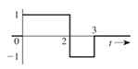
2) Find the power of the two signals below
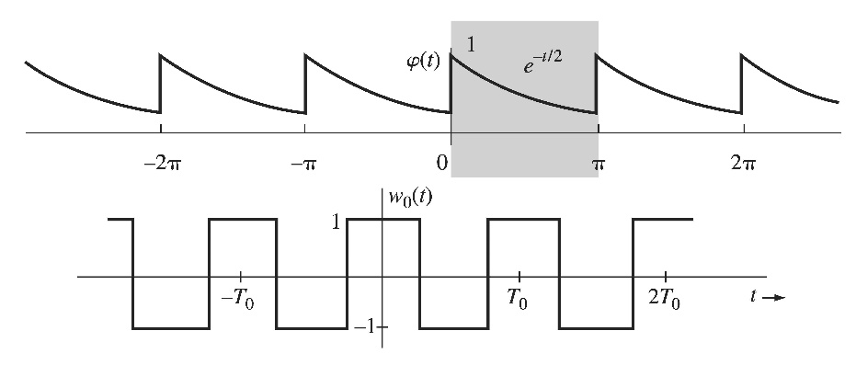
3) for the signal g(t) shown below, sketch the signals a) g(t-4) b) g(-t) c) g(2t-4) 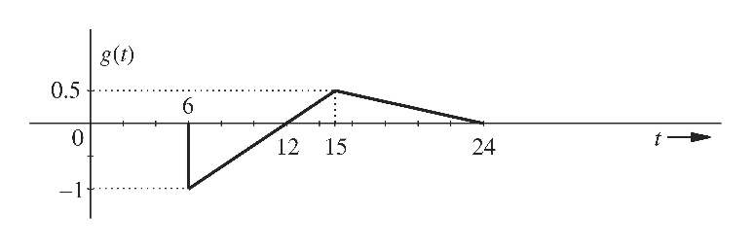
4) For the signal g(t) and x(t) shown below, find the component of the form x(t) contained in g(t). In other words, find the optimum value of c in the approximation g(t) ≈ cx(t) so that the error signal energy is minimum. What is the error signal energy?
5) Find the correlation coefficient ρ between the vector v₁=[2 1 5] and vector v₂=[3 2 4].

6) Find the correlation coefficient ρ between the signal x(t) and each of the four pulses g₁(t), g₂(t), g₃(t), and g₄(t) shown below. To provide maximum margin against the noise along the transmission path, which pair of pulses would you select for a binary communication?
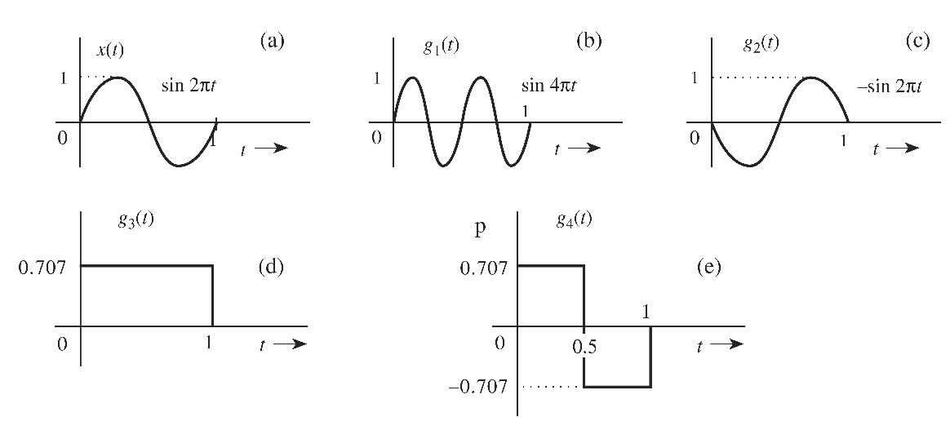

7) a) For the two signals shown below, determine a set of orthonormal basis functions of dimension 2.
b) Determine the vector representation of both g(t) and x(t) using the orthonormal basis from part (a).
8) (a) Sketch signal g(t) = | t | and find the exponential Fourier series to represent g(t) over the interval (-π, π). (b) Verify the Parseval’s theorem by determine the sum of a special infinite series.

