ENGR 4323/5323: Digital and Analog Communication
HW 2_Ch3

1) Consider the signal shown below
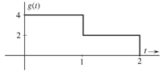
a) Find the Fourier transform of the signal using the definition.
b) Uses the Fourier transform properties to find the Fourier transform of g(-t) and g(2t).
c) Compare the spectrum of g(t), g(-t), and g(2t)

2) Show that the two signals below are totally different in time domain, despite their similarity in frequency domain.
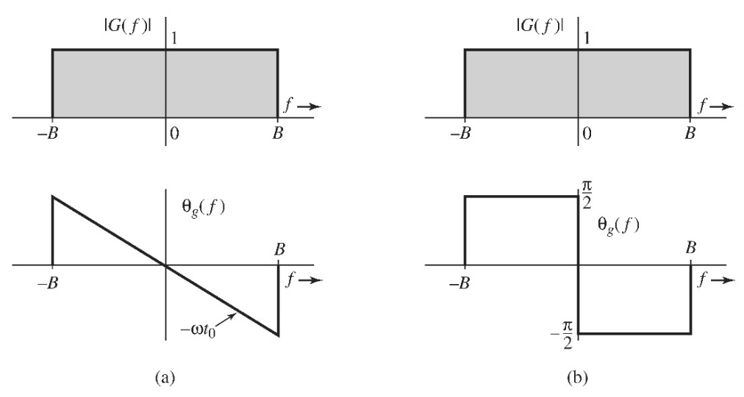
3) The signals below are modulated signals with carrier cos(10t). Find the Fourier transform of these signals using the appropriate properties of the Fourier transform. Sketch the amplitude and phase spectra for Fig. a and b.
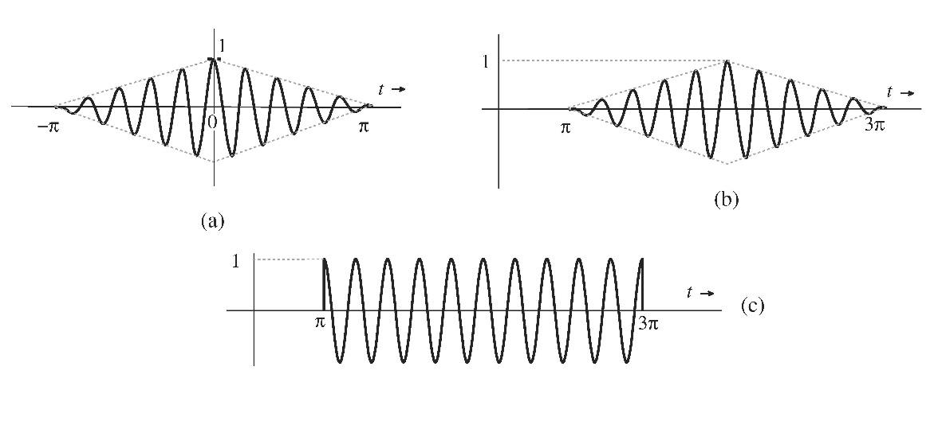
4) Signal g₁(t) = 10³e^{-1000t} u(t) and g₂(t) = δ (t - 100) are applied at the inputs of the ideal lowpass filters H₁(f) = Π(f/2000) and H₂(f) = Π(f/1000). The output y₁(t) and y₂(t) of these filters are multiplied to obtain the signal y(t) = y₁(t)y₂(t).
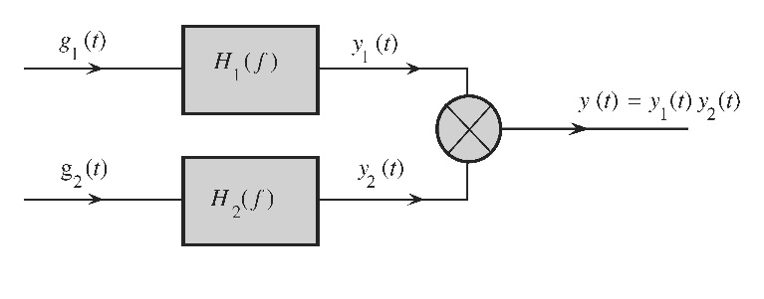
a) Sketch G₁(f) and G₂(f)
b) Sketch H₁(f) and H₂(f).
c) Sketch Y₁(f) and Y₂(f).
d) Find the bandwidths of y₁(t), y₂(t), and y(t).

5) A bandpass signal g(t) of bandwidth B Hz centered at f = 10⁴ Hz is passed through the RC filter below with RC = 10⁻³. If over the passband , the variation of less than 2% in amplitude response and less than 1% in time delay is considered to be distortionless transmission, determine what is the maximum allowable value of bandwidth B in order for g(t) to be transmitted through this RC filter without distortion.
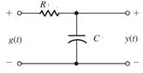
6) The distortion caused by multipath transmission can be partly corrected by a tapped delay equalizer. Show that if α << 1, the distortion in the multipath system in Fig. A below can be approximately corrected if the received signal in Fig. A below passed through the tapped delay equalizer shown in Fig. B below.
Hint: from Eq. (3.64a in text book) $e^{-j2πft_{d}}\left(1+αe^{-j2πf∆t}\right)$. Use the fact that 1/(1-x) = 1 + x + x² + x³ +… if x << 1 to show what the tap parameters a_{i} should be to make the resulting transfer function
H(f)H_{eq}(f) ≈ $e^{-j2πft_{d}}$.

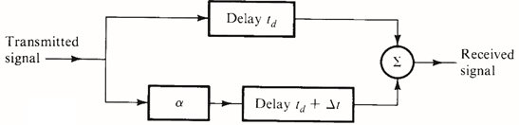
Figure A
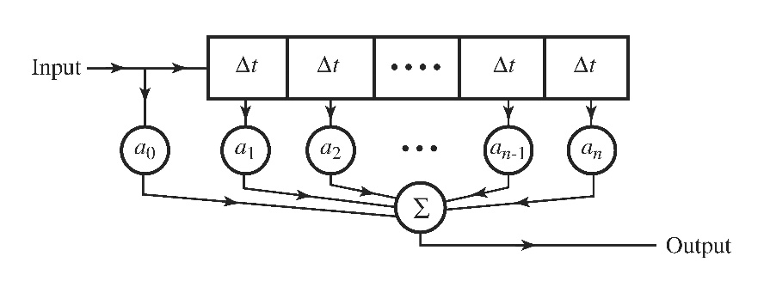
Fig. B
7) For the real valued signal
$$g\left(t\right)=\frac{12a}{{\left(t-t_{0}\right)}^{2}+a^{2}}$$
a) Find the energy density function of this signal
b) Determine in hertz the essential bandwidth B of g(t) such that the energy contained in the spectral components of g(t) of frequencies below B Hz is 99% of the signal energy E_{g}.
Hint: determine G(f) by applying the duality property to a pair in the table.

8) The random binary signal x(t) shown below transmits one digit every T_{b} seconds. A binary 1 is transmitted by a pulse p(t) of width T_{b}/2 and amplitude A: A binary 0 is transmitted by no pulse. The digits 1 and 0 are equally likely and occur randomly. Determine the autocorrelation function $R_{x}(τ)$ and the PSD S_{x}(f).
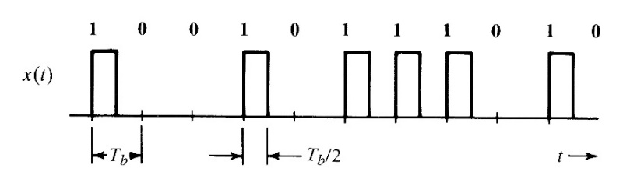
9) Find the mean square value (or power) of the output voltage y(t) of the system shown below if the input voltage PSD S_{x}(f) = Π(0.25πf). Calculate the power (mean square value) of the input signal x(t).
