ENGR 4323/5323: Digital and Analog Communication
HW 3_Ch4

1) Determine and sketch the spectrum of the signal

φ(t) = 2m₁(t)cos(1200πt) + m₂(t)cos(2400πt)

Where we know that m₁(t) = 10 sinc²(200πt - 50π) m₂(t) = 5 sinc(240πt)

2) You are asked to design a DSB-SC modulator to generate a modulated signal Am(t) cos ω_{c}t with the carrier frequency f_{c} = 300 kHz (ω_{c} = 2π x 300,000). The following equipment is available in the stockroom: (i) a sinwave generator of frequency 100 kHz; (ii) a ring modulator; (iii) a bandpass filter with the tuning range of 100 kHz to 500 kHz
- Show how you can generate the desired signal.
- Explain how to tune the bandpass filter.
- If the output of the modulator must be 400m(t) cos ω_{c}t, what should be the amplifier gain to be used on the input m(t) to obtain the desired modulator output signal amplitude?

3) Two signals m₁(t) and m₂(t), both band-limited to 5000 Hz, are to be transmitted simultaneously over a channel by the multiplexing scheme shown below. The signal at point b is the multiplexed signal, which now modulates a carrier of frequency 20,000 Hz. The modulated signal at point c is transmitted over a channel.
- Sketch signal spectra at points a, b, and c.
- What must be the bandwidth of the distortionless channel?
- Design a receiver to recover signals m₁(t) and m₂(t) from the modulated signal at point c.
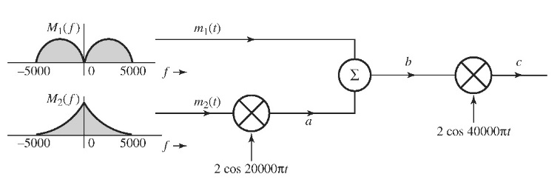
4) A slightly modified version of the scrambler below was first used commercially on the 25-mile radio-telephone circuit connecting Los Angeles and Santa Catalina island, for scrambling audio signals. The output y(t) is the scrambled version of the signal m(t).
  - Find the spectrum of the scrambled signal y(t).
  - Suggest a method of descrambling y(t) to obtain m(t).
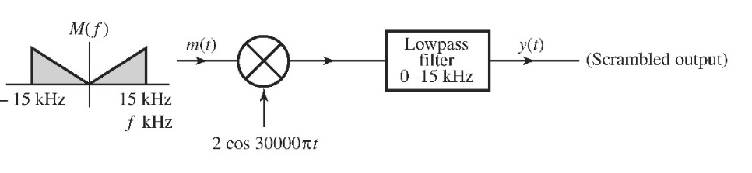
5) a) Sketch the AM signal [B +m(t)]cos(ω_{c}t) for the message signal m(t) shown below corresponding to the modulation index by selecting a corresponding B: (a) μ = 0.5; (b) μ = 1; (c) μ = 2; (d) μ = ∞· Is there any pure carrier component for the case μ = ∞? How do you interpret the case μ = ∞?
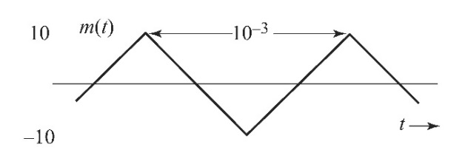
b) For μ = 2, find the amplitude and power of the carrier.
c) For μ = 2, find the sideband power and the power efficiency η.
6) In the early days of radio, AM signals were demodulated by a crystal detector followed by a low-pass filter and a dc blocker, as shown below. Assume a crystal detector to be basically a squaring device. Determine the signals at points a, b, c, and d. Point out the distortion term in the output y(t). Show that if A >> |m(t)|, the distortion is small.

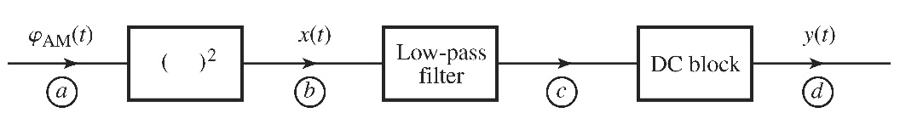
7) A modulating signal m(t) is given by:
- m(t) = cos 100πt + 2 cos 300πt
- m(t) = sin 100πt sin500πt

In each case:
- Sketch the spectrum of m(t).
- Find and sketch the spectrum of the DSB-SC signal 2m(t)cos(1000πt).
- From the spectrum obtained in part (ii), suppress the LSB spectrum to obtain the USB spectrum
- Knowing the USB spectrum in part (ii), write the expression ϕ_{USB}(t) for the USB signal.
- Repeat (iii) and (iv) to obtain the LSB signal ϕ_{LSB}(t) in both time and frequency domains.
- Use the equation 4.20 in textbook to determine the time domain expressions ϕ_{LSB}(t) and ϕ_{USB}(t).
8) A vestigial filter H_{i}(f) shown in the transmitter below has a transfer function as shown below. The carrier frequency is f_{c} = 10 kHz and the baseband signal bandwidth is 4 kHz. Find the corresponding transfer function of the equalizer filter H₀(f) shown in the receiver below.
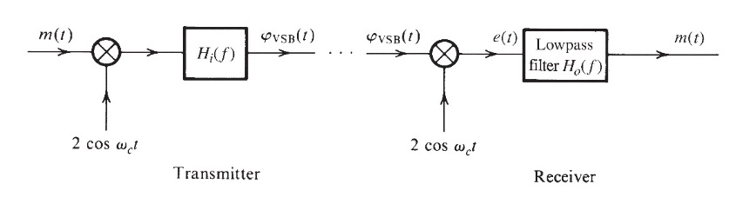
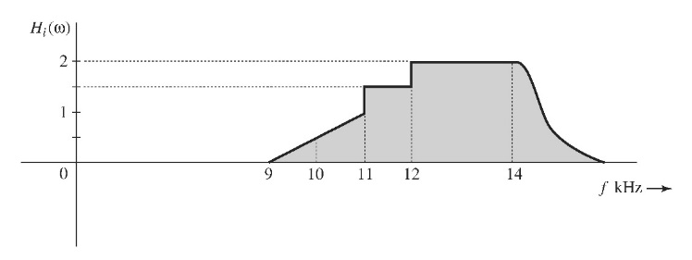
9) A transmitter must send a multimedia signal m(t) with bandwidth of 450 kHz. Its assigned bandwidth is [2.3 MHz, 2.8 MHz]. As shown in the transmitter diagram of figure below, this is an ideal BPF H_{T}(f) at the transmitter.
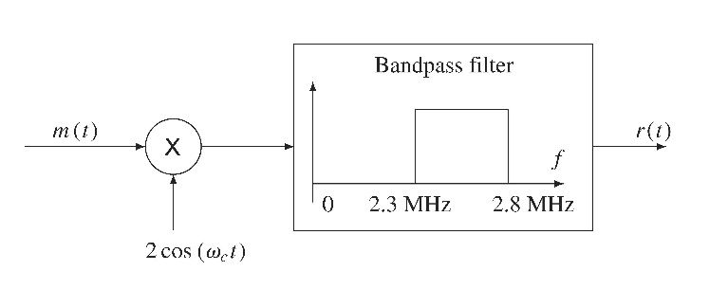
- Complete the design of the VSB system for carrier frequency of 2.354 MHz in the above figure by specifying the carrier frequency and a detailed receiver system block diagram.
- For distortionless detection, derive and plot the receiver filter frequency response needed at the front end of the demodulator.

