ENGR 4323/5323: Digital and Analog Communication
HW 4_Ch4
1) A baseband signal m(t) is the periodic sawtooth signal shown below.
- Sketch φ_{FM}(t) and φ_{PM}(t) for this signal m(t) if ω_{c} = 2π x 10⁶ rad/s, k_{f} = 2000π, and k_{p} = π/2.
- Show that the PM signal is a signal with constant frequency but periodic phase changes. Explain why it is necessary to use k_{p} < π in this case for reception purpose. [Note that the PM signal has a constant frequency but has phase discontinuities corresponding to the discontinuities of m(t).]
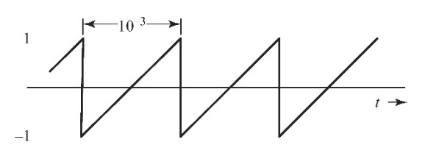
2) Over an interval |t| ≤ 1, an angle-modulated signal is given by φ_{EM}(t) = 10 cos(13,000 πt + 0.3 π). It is known that the carrier frequency ω_{c} = 12,000π.
- Assuming the modulated signal is a PM signal with k_{p} = 1000, determine m(t) over the interval |t| ≤ 1.
- Assuming the modulated signal is a FM signal with k_{f} = 1000, determine m(t) over the interval |t| ≤ 1.

3) A periodic message signal m(t) as shown below is to be transmitted by using angle modulation. Its bandwidth is approximated by 200 Hz. The modulation system has ω_{c} = 4,000π rad/s.
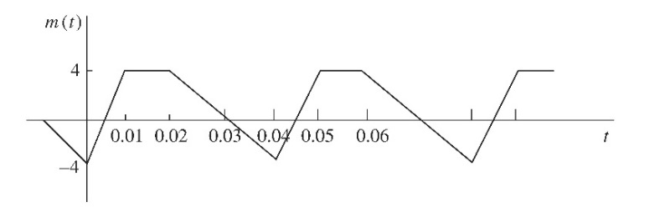
- If an FM signal with k_{f} = 500π is to be generated, sketch the FM signal in the time domain.
- If a PM signal with k_{p} = 0.25π is to be generated, sketch the PM signal in the time domain.

4) For the modulated signal in the above problem (problem 3), we can approximate the bandwidth of the periodic message signal m(t) using 7/T where T is its period, also known as its seventh harmonic frequency.

- Determine the approximate bandwidth of the FM signal.
- Determine the approximate bandwidth of the PM signal.

5) An angle-modulated signal with carrier frequency ω_{c} = 2π x 10⁶ is

ϕ_{EM}(t) = 5 cos (ω_{c} t + 20 cos1000πt + 10 sin 4000πt)

- Find the power of the modulated signal.
- Find the frequency deviation Δf.
- Find the phase deviation Δφ.
- Estimate the bandwidth of ϕ_{EM}(t).

6) A periodic square wave m(t), shown in Fig. a below, frequency-modulates a carrier of frequency f_{c} = 10 kHz with Δf = 1 kHz. The carrier amplitude is A. The resulting FM signal is demodulated, as shown in Fig. b below, by the method discussed in Sec. 5.4 (Sec. 4.7). Sketch the waveforms at points b, c, d, and e.
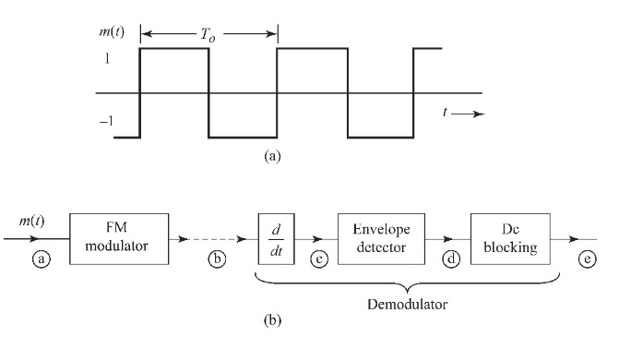
7) Let s(t) be an angle-modulated signal that arrives at a receiver,

s(t) = 2 cos [10⁷π t + 2 sin(1000πt + 0.3π) - 3 cos(2000πt)]

- Find the bandwidth of this FM signal.
- If s(t) is sent to an (ideal) envelop detector, find the detector output signal.
- If s(t) is first differentiated before the envelop detector, find the detector output signal.
- Explain which detector output can be processed to yield the message signal m(t) and find the message signal m(t) if k_{f} = 200π.

8) Consider a superheterodyne FM receiver designed to receive the frequency band of 88 to 108 MHz with IF of 10.7 MHz. What is the range of frequencies generated by the local oscillator for this receiver? Analyze and explain whether it is possible for an FM receiver to receive both a desired FM station and an image FM station when tuned to the desired frequency.

9) Design (the block diagram) an Armstrong indirect FM modulator to generate an FM carrier with a carrier frequency of 96 MHz and Δf = 20 kHz. A narrow-band FM generator with f_{c} = 200 kHz and adjustable Δf in the range of 9 to 10 Hz is available. The stock room also has an oscillator with adjustable frequency in the range of 9 to 10 MHz. There is a bandpass filter with any center frequency, and only frequency doublers are available.

10) The license-free IEEE802.11 radio, also known as the Wi-Fi, can operate in the 2.4 GHz industrial, scientific, and medical (ISM) radio band that has a frequency range of 2.4-2.4835 GHz. Each Wi-Fi transmission takes 22 MHz bandwidth.

- Determine how many non-overlapping channels can be accommodated in the 2.4 GHz ISM band.
- IEEE 802.11 standard allows 13 overlapping channel settings in this band from channel 1 (entered at 2.412 GHz) up to Channel 13 (centered at 2.472 GHz). Adjacent channel center frequencies are 5 MHz apart. If one of your close neighbors has set up his/her Wi-Fi on Channel 4 centered at 2.427 GHz, what are possible channel settings you should use for your Wi-Fi network in this ISM band to avoid interference?

