**ENGR 4323/5323: Digital and Analog Communication**

**HW 5A_Ch5**

**1)** A Determine the Nyquist sampling rate and the Nyquist sampling interval for the signals:

1. 4 sinc (420πt);
2. 5 sinc2 (6500πt);
3. sinc(1800πt) + sinc2(2000πt);
4. 2 sinc(500πt)sinc(300πt).

**2)** A zero-order hold circuit shown below is often used to reconstruct a signal *g*(*t*) from its samples.

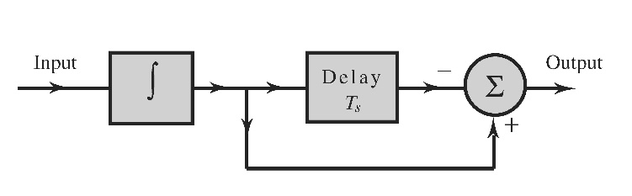

1. Find the unit impulse response of this circuit.
2. Find and sketch the transfer function *H*(*f*)
3. Show that when a sampled signal $\overline{g}(t)$ is applied at the input of this circuit, the output is a staircase approximation of *g(t).* The sampling interval is *T*s.

**3)** Consider a bandlimited signal *g*1(*t*) whose Fourier transform is

*G*1(*f*) = 5.Δ(*f* / 800)

1. If *g*1(*t*) is uniformly sampled at the rate of *fs* = 400 Hz, show the resulting spectrum of the ideally sampled signal.
2. If we attempt to reconstruct the *g*1(*t*) from the samples in Part (a), what will be the recovered analog signal in both time and frequency domains?
3. Determine another analog signal *G*2(*f*) in frequency domain such that its samples at *fs* = 400 Hz will lead to the same spectrum after sampling as in Part (a).
4. Confirm the results of (c) by comparing the two sample sequences in time domain.

**4)** A first-order-hold circuit can also be used to reconstruct a signal *g*(*t*) from its samples. The impulse response of this circuit is

$h\left(t\right)=∆\left(\frac{t-T_{s}}{2T_{s}}\right)$ where *Ts* is the sampling interval.

1. Consider a typical sampled signal $\overline{g}(t)$ and show that this circuit performs the linear interpolation. In other words, the filter output consists of sample tops connected by straight-line segments.
2. Determine the transfer function of this filter and its amplitude response, and compare it with the ideal filter required for signal reconstruction.

**5)** A television signal (video and audio) has a bandwidth of 4.5 MHz. This signal is sampled, quantized, and binary coded to obtain a PCM signal.

1. Determine the sampling rate if the signal is to be sampled at a rate 22% above the Nyquist rate.
2. If the samples are quantized into 1024 levels, determine the number of binary pulses required to encode each sample.
3. If 2% more bits are added to the multiplexed data for error protection and synchronization, determine the minimum bandwidth required to transmit the final data stream to receivers.