ENGR 4323/5323: Digital and Analog Communication
HW 5_Ch5

1) A Determine the Nyquist sampling rate and the Nyquist sampling interval for the signals:
- 4 sinc (420πt);
- 5 sinc² (6500πt);
- sinc(1800πt) + sinc²(2000πt);
- 2 sinc(500πt)sinc(300πt).

2) A zero-order hold circuit shown below is often used to reconstruct a signal g(t) from its samples.
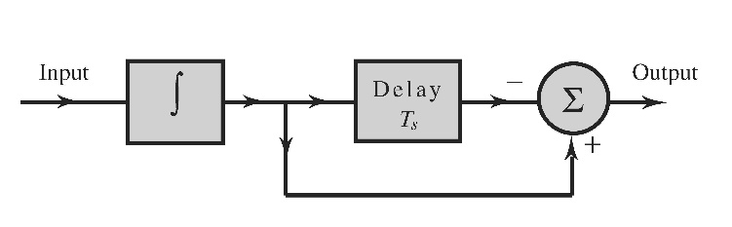
- Find the unit impulse response of this circuit.
- Find and sketch the transfer function H(f)
- Show that when a sampled signal $\overline{g}(t)$ is applied at the input of this circuit, the output is a staircase approximation of g(t). The sampling interval is T_{s}.

3) Consider a bandlimited signal g₁(t) whose Fourier transform is

G₁(f) = 5.Δ(f / 800)

- If g₁(t) is uniformly sampled at the rate of f_{s} = 400 Hz, show the resulting spectrum of the ideally sampled signal.
- If we attempt to reconstruct the g₁(t) from the samples in Part (a), what will be the recovered analog signal in both time and frequency domains?
- Determine another analog signal G₂(f) in frequency domain such that its samples at f_{s} = 400 Hz will lead to the same spectrum after sampling as in Part (a).
- Confirm the results of (c) by comparing the two sample sequences in time domain.

4) A first-order-hold circuit can also be used to reconstruct a signal g(t) from its samples. The impulse response of this circuit is
$h\left(t\right)=∆\left(\frac{t-T_{s}}{2T_{s}}\right)$ where T_{s} is the sampling interval.

- Consider a typical sampled signal $\overline{g}(t)$ and show that this circuit performs the linear interpolation. In other words, the filter output consists of sample tops connected by straight-line segments.
- Determine the transfer function of this filter and its amplitude response, and compare it with the ideal filter required for signal reconstruction.

5) A television signal (video and audio) has a bandwidth of 4.5 MHz. This signal is sampled, quantized, and binary coded to obtain a PCM signal.
- Determine the sampling rate if the signal is to be sampled at a rate 22% above the Nyquist rate.
- If the samples are quantized into 1024 levels, determine the number of binary pulses required to encode each sample.
- If 2% more bits are added to the multiplexed data for error protection and synchronization, determine the minimum bandwidth required to transmit the final data stream to receivers.

6) The output SNR of a 10-bit PCM (n = 10) was found to be 30 dB. The desired SNR is 42 dB. It was decided to increase the SNR to the desired value by increasing the number of quantization levels L. Find the fractional increase in the transmission bandwidth required for this increase in L.

7) A message signal m(t) is normalized to peak voltage of ±1 V. The average message power equals 120 mW. To transmit this signal by binary PCM without compression, uniform quantization is adopted. To achieve a required SNR of at least 36 dB, determine the minimum number of bits required to code the uniform quantizer. Determine the actual SNR obtained with this newly designed uniform quantizer.

8) Repeat problem 7 if a μ-law compandor is applied with μ = 100 to achieve a non-uniform quantizer.

9) The American Standard Code for Information Interchange (ASCII) has 128 binary-coded characters. If a certain computer generates data at 600,000 characters per second, determine the following:

- The number of bits (binary digits) required per character.
- The number of bits per second required to transmit the computer output, and the minimum bandwidth required to transmit this signal.
- For single error-detection capability, an additional bit (parity bit) is added to the code of each character. Modify your answers in parts (a) and (b) in view of this information.
- Show how many DSI carriers would be required to transmit the signal of part © in the North American digital hierarchy.

10) Consider a simple DPCM encoder in which N = 1 is used for m(t) = A_{m} cos(ω_{m}t + θ_{m}). The sampling interval is T_{s} such that m[k] = m(kT_{s}) with θ_{m} = 0.5ω_{m}T_{s}. The first-order estimator is formed by

${\hat{m}}_{q}\left[k\right]=m\left[k-1\right]$

With prediction error

${d\left[k\right]=m\left[k\right]-\hat{m}}_{q}\left[k\right]$
d[k] = A_{m} cos(kω_{m} T_{s} + θ_{m}) - A_{m} cos(kω_{m} T_{s} + θ_{m} - ω_{m} T_{s})

- Determine the peak value of d[k].
- Evaluate the amount of SNR improvement in dB that can be achieved by this DPCM over a standard PCM.

11) A DM system has input message signal

m(t) = 50e^{-200t} cos(1000πt).u(t)

- Determine the minimum step size E necessary to avoid DM slope overload.
- Calculate the minimum average quantization noise power based on part (a).

Bonus Question: In a nonideal sampler, the following pulse

q_{a}(t) = Δ(2t/T_{s})

is used as the time-averaging filter impulse response. The sampling rate f_{s} is selected to be higher than the Nyquist frequency. Design a reconstructed system diagram to recover the original analog signal. Determine all the necessary filter responses. (see section nonideal practical A/D sampling analysis)

