**ENGR 4323/5323: Digital and Analog Communication**

**HW 6_Ch6**

**1)** A binary data sequence 01001010110… is transmitted by means of the line codes listed below where the bit duration *T*b is 1 microsecond. Sketch the transmitted waveform for the following line codes. Use a rectangular pulse for the pulse waveform.

a) On-Off (RZ)

b) Polar (RZ)

c) Bipolar (RZ)

d) On-Off (NRZ)

e) Polar (NRZ)

f) Manchester

**2)** List the main advantage and disadvantage of each of the following line codes:

a) On-Off (RZ)

b) Polar (RZ)

c) Bipolar (RZ)

d) On-Off (NRZ)

e) Polar (NRZ)

f) Manchester

**3)** What are the major criteria of an ideal pulse shape for bit transmission?

**4)** Indicate the advantage and disadvantage of the following pulse shapes *p*1(*t*) = Δ(*t*/Tb) and *p*2(t) = П(t/Tb)

**5)** Consider the scrambler below

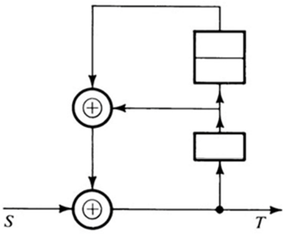

a) If a sequence *S* = 1001011001110101… is applied to the input of this scrambler, determine the output sequence *T*.

b) Design a corresponding descrambler.

**6)** If the input to a binary differential *PSK* modulation system is 1011001011… , derive and tabulate the following results:

a) differential encoder output

b) modulated phase value *θ*k

c) modulated phase difference *θ*k – *θ*k-1

d) decision rule of the detector

**7)** Consider an *M*-ary *FSK* carrier modulated signal for which the data rate is 2.4 Mbit/s, and the carrier frequency is *f*c = 900 MHz.

a) Find the minimum frequency separation for this *FSK* and design the specific frequencies for this *FSK* modulator centered at carrier frequency of *f*c = 900 MHz.

b) Determine the estimated bandwidth of this *M*-*FSK* carrier modulation for *M* = 4.