ENGR 4323/5323: Digital and Analog Communications

Test 1 (2/26/19)

Time: 75 minutes Name:

t
Fig. 2
1
2
g(t)
t
1
2
x(t) = 2e^{-2t}
Fig. 1
x(t)
1-20pts) Find the correlation coefficient ρ between the signal x(t) and g(t) shown in Fig. 1 and Fig. 2.

2-20pts) Find the Fourier transform of the signal x(t) shown in Fig. 1.

3-20pts) For the system shown in Figure below.
a) Graphically find and show the spectra of signals x(t), y(t), and z(t) when ω_{o} = 40,000π.
b) Find the energy of the signal m(t).

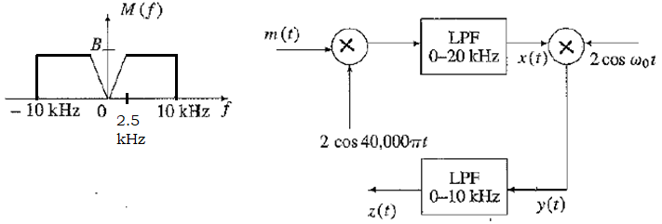

4-20pts) A transmission channel is modeled by the impulse response h(t) = e^{-3t} u(t).
- Find the transfer function H(s) and the frequency response H(ω).
- Find the received signal y(t) if the transmitted signal is x(t) = 1 + 2δ(t- 2) – cos (4t). This is equivalent to finding the output y(t) of the system described by h(t) to the input x(t) = 1 + 2δ(t- 2) – cos (4t).

5-20pts) The input x(t) and the output y(t) of a certain nonlinear channel are related as

y(t) = x(t) + 0.000158 x²(t)

Find the output signal y(t) and its spectrum Y(f) if the input signal is x(t) = 2000 sinc(2000πt). Verify that the bandwidth of the output signal is twice that of the input signal. Can the signal x(t) be recovered (without distortion) from the output y(t)? Explain your answer.

