**ENGR 4323/5323: Digital and Analog Communications**

**Time:** 75 minutes **Name:**

**Solve only 4 problems from the 5 problems listed below.**

**1-25pts)** In a DSB-SC amplitude modulation system, the message signal is *m*(*t*) = 200 sinc(200πt) and the carrier signal is cos(2000πt).

a) Find and sketch the Fourier transform magnitude of the message signal.

b) Find and sketch the Fourier transform magnitude of the modulated signal.

**2-25pts)** For the signals *m*1(*t*) = *A* cos 200π*t*, *m*2(*t*) = *B* cos 400π*t*, and the carrier cos 1000π*t*, label the type of modulation used in the following modulated signals *ϕ*(*t*).

a) *ϕ*(*t*) = *A* cos 200π*t* cos 1000π*t* + *B* cos 400π*t* sin 1000π*t*

b) *ϕ*(*t*) = cos (1000π*t* + 0.2 *A* cos 200π*t* )

c) *ϕ*(*t*) = *A* cos 200π*t* cos 1000π*t*

d) *ϕ*(*t*) = cos (1000π*t* + 2 *A* sin 200π*t* )

e) *ϕ*(*t*) = *A* cos 1200π*t*

f) *ϕ*(*t*) = 10 cos 1000π*t* + *A* cos 200π*t* cos 1000π*t*

**3-25pts)** The system below is used for modulation with carrier frequency ωc = 600π to transmit the signal

*m*(*t*) = cos 200π*t*.

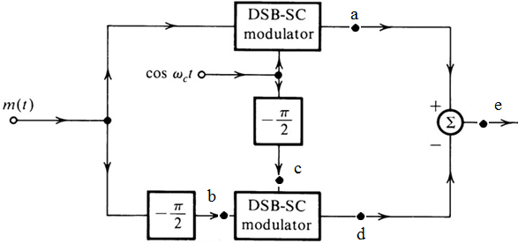

1. Find the mathematical expression of the signals in nodes a, b, c, d, e.
2. Sketch signal magnitude spectrum at point e.
3. What type of modulator is the system?

**4-25pts)** Design an Armstrong indirect FM modulator in block diagram to generate an FM signal with carrier 96.3 MHz and Δ*f* = 20.48 kHz. A narrowband FM generator with *fc* = 150 kHz and Δ*f* = 10 Hz is available. Only a limited number of frequency doublers are available as frequency multipliers. In addition, an oscillator with adjustable frequency from 13 to 14 MHz is also available for mixing, along with bandpass filters of any specification.

**5-25pts)** A periodic signal *m*(*t*) is approximated by its first two harmonics as follow:

$m\left(t\right)=[3+2cos200πt+0.5cos600πt]u(t)$

1. Write expressions for $φ_{PM}(t)$ and $φ_{FM}(t)$ when the carrier amplitude *A* =10, ωc = 2000π, *kf* = 400π, *kp* = 0.5.
2. Find the frequency deviation Δ*f* of $φ_{PM}(t)$ and $φ_{FM}(t)$
3. Estimate the Bandwidth of $φ_{PM}(t)$ and $φ_{FM}\left(t\right).$
4. What is the advantage and disadvantage of increasing the value of *kf* ?