**Digital Signal Processing ENGR 4333/5333**

**Test 1**

**Date:** 3/7/2022  **Time:** 90 minutes **Name:**

1

2

3

4

2

4

6

*x*[*n*]

*n*

Fig. 1

5

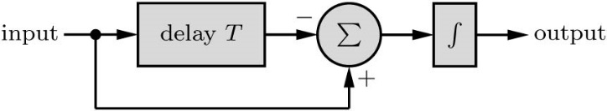

Fig. 2

**Q1)** Find the energy of the signal shown in Fig. 1

**Q2**) Plot the signal *x*[3 - *n*] where *x*[*n*] is shown in Fig. 1.

**Q3**) Plot the signal *y*[*n*] = *n* (*u*[*n*] – *u*[*n*-5])

**Q4**) The signal *x*(*t*) = cos(50π*t*) is sampled at a sampling rate 200 samples/second. Find the discrete signal *x*[*n*].

**Q5)** What is the digital frequency and the fundamental period of the signal *x*[*n*]=cos(0.3πn)

**Q6)** Find the impulse response *h*(*t*) of the system shown in Fig. 2 above.

**Q7)** A TV signal (video and audio) has a bandwidth of 4 MHz. This signal is sampled, quantized, and binary coded.

1. Determine the sampling rate if the signal is to be sampled at a rate 25% above the Nyquist rate.
2. If the samples are quantized into 512 levels, determine the number of binary pulses required to encode each sample.
3. Determine the binary pulse rate (bits/s) of the binary coded signal.

**Q8)** A signal *x*(*t*) is converted to a binary signal. If the signal-to-quantization-noise ratio (SQNR) is required to be at least 60 dB, determine the minimum number of quantization levels *L* required, if the power of the signal *x*(*t*) is 5 watts. Determine the actual SQNR obtained with this minimum *L*.

**Q9)** Find a difference equation, including initial conditions, that approximates the behavior of the second-order difference equation *d*2*y*(*t*)/*dt*2 + 3*y*(*t*) = *dx*(*t*)/*dt,* where *y*(0) = 0 and d*y*(0)/dt = 3. Take the sampling interval as *T* = 0*.*05.

**Q10)** Is the system *y*[*n*] = *nx*[*n −* 1] time invariant?